**Experiment No:** 06

**Experiment title:** Measurement of parameters and I-V characteristics of an N-channel MOSFET.

**Circuit Diagram:**

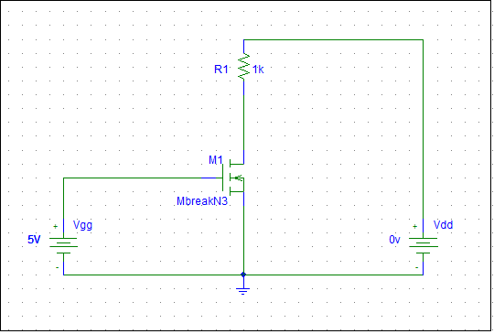

Figure 1: Circuit for measurement of I-V characteristics of an N-Channel MOSFET

**Equipments:**

1. Digital trainer board
2. DC power supply
3. Digital multimeter
4. DC Voltmeter
5. CD4007C IC (1pc)
6. Resistor (1KΩ 1 pc)
7. Breadboard
8. Connecting wires

**Post lab Question Answer**

1. **Measured:**



**Calculated:**



1. Calculted value of ID in saturation region= 5.14 mA and experimental value of ID in saturation region =0.99. so experimental value is lower than calculated value because of temperature and problem in measurement.
2. rD = = = =0.1538KΩ

**4.**





**Conclusion:**

Learn characteristics of amplifier, its behaver and working principles.There are some difference in measured value and calculated value for temperature, equipment’s error or ignored value after decimal.

**EAST WEST UINVERSITY**

**Department of Computer Science and Engineering**

**Post Lab**

**Semester:** Summer’17

**Course code:** CSE 251 (2)

**Course title:** Electronic Circuits

**Experiment No:** 06

**Experiment title:** The Measurement of Parameters and I-V Characteristics of an N-channel MOSFET

**Submitted to:**

Surajit Das Barman

Senior Lecturer

Department of CSE

East West University

**Submitted by:**

Kowser Mahmud Tanim

ID: 2015-2-60-062

Group No: 05

Group IDs: 2015-2-60-078, 2015-2-60-057, 2015-2-60-108

**Date of performance:** 25/07/2017

**Date of report submission:** 09/08/2017